*NOTE: I have swapped the angles because I prefer using cos for X-Direction and sin for Y-Direction. The answers should stay the same.
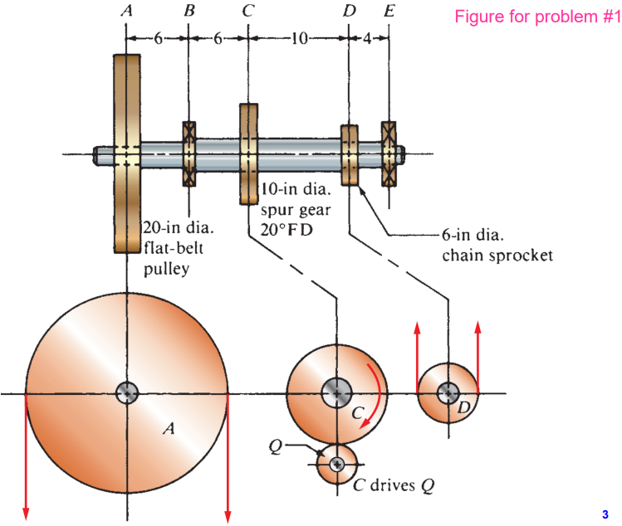
1. The shaft shown in the figure rotates at 200 rpm. The pulley A receives 20 hp from below. The gear C delivers 12 hp to the mating gear below it, and the chain sprocket D delivers the rest 8 hp to a shaft above. The shaft material is SAE 1117 cold-drawn steel. Take 𝐶𝑠 = 0.80, 𝐶𝑅 = 0.81, design factor 𝑁 = 2, stress concentration factor 𝐾𝑡 = 3. (20’ in total)
1) Determine the torques on pully A, gear C, and sprocket D. Also determine the torque distribution in A-C, C-D, and D-E region.
2) Plot the shear and bending moment diagrams of the entire shaft in the horizontal and vertical planes.
3) Determine the total bending moment at point B, C, and D.
4) Determine the minimum acceptable diameters for the shaft at point C (do design to the left and to the right separately)

(A)
$$T_{A}=T_{AC}=\frac{63000*hp}{rpm}=63000*\frac{20}{200}=6300\left[lb*in\right]$$
$$T_{C}=\frac{63000*hp}{rpm}=63000*\frac{12}{200}=3780\left[lb*in\right]$$
$$T_{D}=T_{CD}=\frac{63000*hp}{rpm}=63000*\frac{8}{200}=2520\left[lb*in\right]$$
$$T_{DE}=0$$
(B)
$$F_{A}=2*\frac{T}{\left(D/2\right)}=2*\frac{6300}{10}=1260$$
$$F_{Ay}=1260*sin\left(270°\right)=-1260\left[lb\right]$$
$$F_{Cx}=\frac{T}{\left(D/2\right)}=\frac{3780}{5}=756\left[lb\right]$$
$$F_{Cy}=\frac{T}{\left(D/2\right)}*\tan\left(θ\right)=756*\tan\left(20°\right)=275.161497\left[lb\right]$$
$$F_{Dy}=\frac{T}{\left(D/2\right)}=\frac{2520}{3}*sin\left(90°\right)=840\left[lb\right]$$
Y-Axis Moment/Shear Diagram
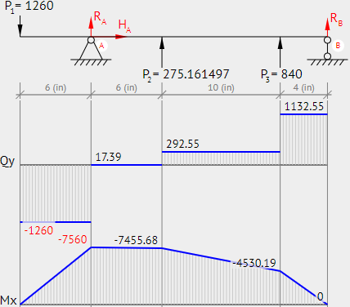

X-Axis Moment/Shear Diagram
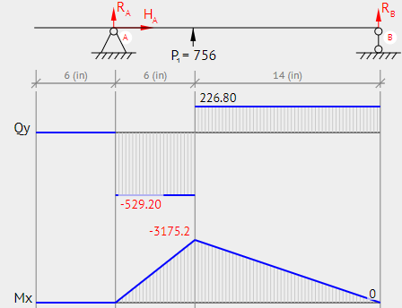
(C)
Bending Moment At B
$$M_{B}=\sqrt{{7560}^{2}+0^{2}}=7560$$
Bending Moment At C
$$M_{C}=\sqrt{{7455.68}^{2}+{3175.2}^{2}}=8103.64$$
Bending Moment At D
$$M_{D}=\sqrt{{4530.19}^{2}+{907.2}^{2}}=4620.13$$
(D)
From appendix 3: $S_{u}=80, S_{y}=65$
From Fig 5-11a:$S_{n}≅31 ksi$
$$S_{n}^{'}=31*0.81*0.8*1*1=20.088 [ksi]$$
$$D_{Right}={\left(\frac{32*2}{π}*\sqrt{{\left(\frac{3*8103.64}{20088}\right)}^{2}+\frac{3}{4}{\left(\frac{2520}{65000}\right)}^{2}}\right)}^{\frac{1}{3}}=2.911\left[in\right]$$
$$D_{Left}={\left(\frac{32*2}{π}*\sqrt{{\left(\frac{3*8103.64}{20088}\right)}^{2}+\frac{3}{4}{\left(\frac{6300}{65000}\right)}^{2}}\right)}^{\frac{1}{3}}=2.913\left[in\right]$$

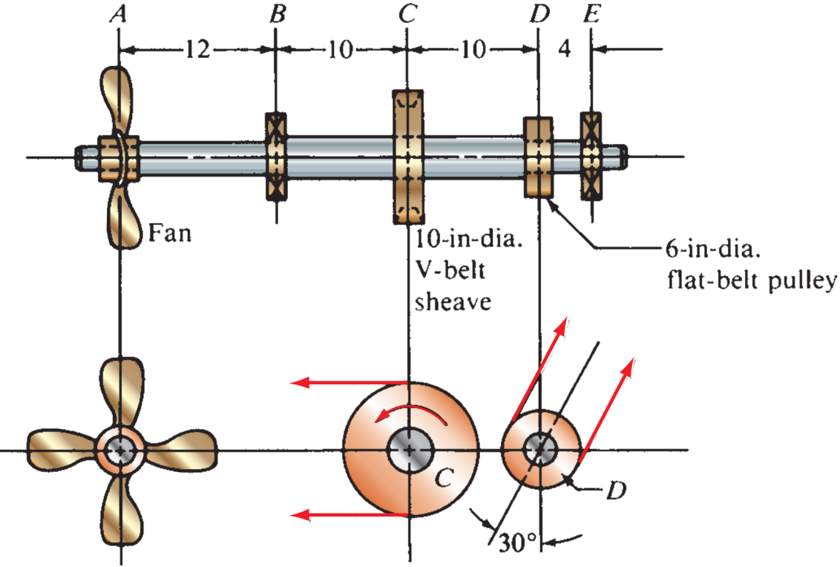
2. The shaft shown is part of a grain-drying system. At point A is a propeller-type fan that requires 12 hp when rotating at 475 rpm. The fan weighs 34 lb, and its weight should be included in the analysis. The flat-belt pulley at point D delivers 3.5 hp to a screw conveyor handling the grain. All power goes into the shaft through the V-belt sheave at point C. Use SAE 1144 cold-drawn steel for the shaft material. (20’ in total)
1) Determine the torques at A, C, and D. Also determine the torque distribution in A-C, C-D, and D-E region.
2) Plot the shear and bending moment diagrams of the entire shaft in the horizontal and vertical planes.
3) Determine the total bending moment at point C and D.
4) Determine the minimum acceptable diameters for the shaft at point C. Do the design to the left and to the right of point C separately. Take 𝐶𝑠 = 0.85, 𝐶𝑅 = 0.81, design factor 𝑁 = 3, stress concentration factor 𝐾𝑡 = 2.0 (Keyseat) and 𝐾𝑡 = 3.0 (Ring groove) to the left and to the right of point C, respectively.

(A)
$$T_{A}=T_{AC}=\frac{63000*hp}{rpm}=\frac{63000*12}{475}=\frac{30240}{19}≅1591.58$$
$$T_{D}=T_{CD}=\frac{63000*hp}{rpm}=\frac{63000*3.5}{475}=\frac{8820}{19}≅464.21$$
$$T_{C}=\frac{63000*hp}{rpm}=\frac{63000*15.5}{475}=\frac{39060}{19}≅2055.789$$
$$T_{DE}=0$$

(B) Down is negative, and up is positive.
$$F_{A}=34;F_{A_{X}}=0;F_{A_{Y}}=-34$$
$$F_{C}=1.5*\frac{T}{\left(D/2\right)}=1.5*\frac{\left(\frac{39060}{19}\right)}{5}=\frac{11718}{19}≅616.7368;F_{C_{X}}=\frac{11718}{19}*\cos\left(180°\right)≅-616.7368;F_{C_{Y}}=0$$
$$F_{D}=2*\frac{T}{\left(D/2\right)}=2*\frac{\left(\frac{8820}{19}\right)}{3}=\frac{5880}{19}≅309.4737;F_{D_{X}}=\frac{5880}{19}*\cos\left(60°\right)≅154.737;F_{D_{Y}}=\frac{5880}{19}*\sin\left(60°\right)≅268.012$$
X-Direction:
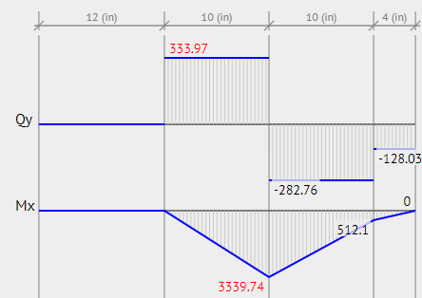
Y-Direction:
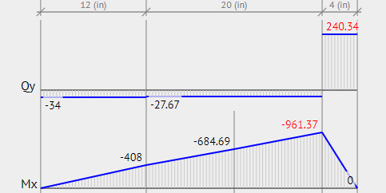

(C)
$$M_{C}=\sqrt{{3339.74}^{2}+{684.69}^{2}}=3409.2$$
$$M_{D}=\sqrt{{512.1}^{2}+{961.37}^{2}}=1089.3$$
(D)
From appendix 3: $S_{u}=100, S_{y}=90$
From Fig 5-11a:$S_{n}≅37 ksi$
$$S_{n}^{'}=s_{n}*C_{m}*C_{st}*C_{R}*C_{s}=37*0.81*0.85*1*1=25.4745 [ksi]$$
$$D_{CRight}={\left(\frac{32*N}{π}*\sqrt{{\left(\frac{K_{t}M}{s_{n}^{'}}\right)}^{2}+\frac{3}{4}{\left(\frac{T}{s_{y}}\right)}^{2}}\right)}^{1/3}={\left(\frac{32*3}{π}*\sqrt{{\left(\frac{3*3409.2}{25475}\right)}^{2}+\frac{3}{4}{\left(\frac{464.21}{90000}\right)}^{2}}\right)}^{\frac{1}{3}}=2.3\left[in\right]$$
$$D_{CLeft}={\left(\frac{32*N}{π}*\sqrt{{\left(\frac{K_{t}M}{s_{n}^{'}}\right)}^{2}+\frac{3}{4}{\left(\frac{T}{s_{y}}\right)}^{2}}\right)}^{1/3}={\left(\frac{32*3}{π}*\sqrt{{\left(\frac{2*3409.2}{25475}\right)}^{2}+\frac{3}{4}{\left(\frac{1591.58}{90000}\right)}^{2}}\right)}^{\frac{1}{3}}=2.016\left[in\right]$$

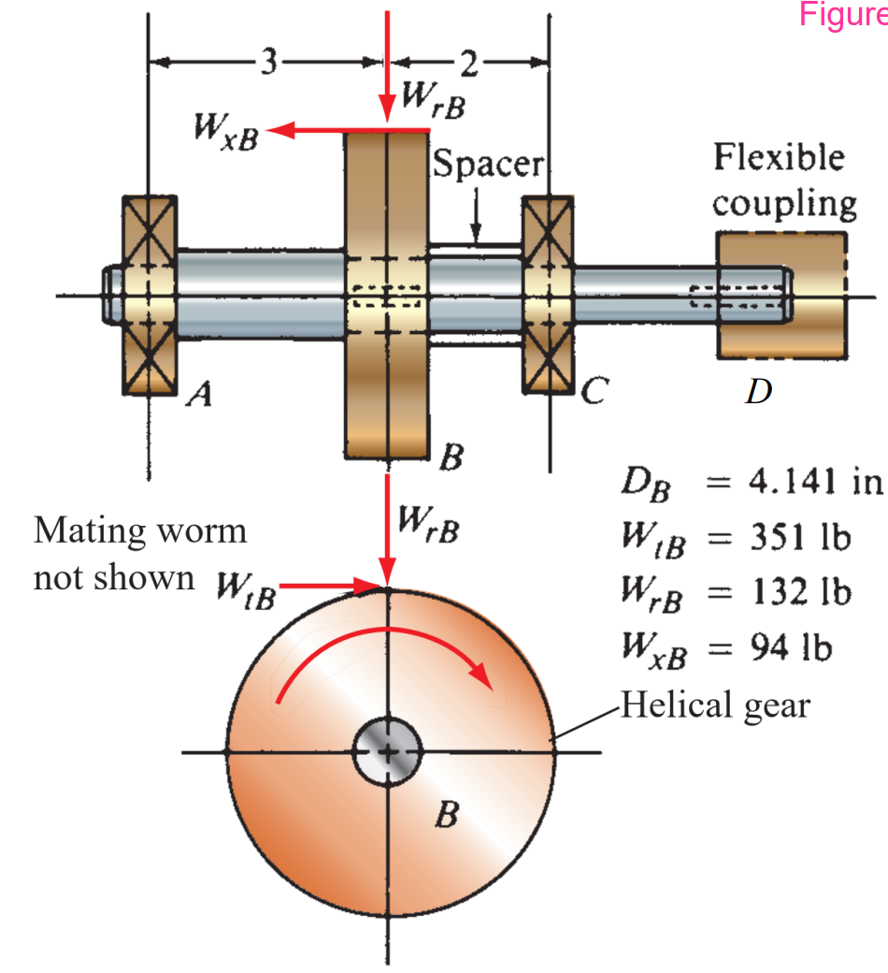
3. A helical gear mounted on a shaft that rotates at 650 rpm while transmitting 7.5 hp. The tangential, radial, and axial forces on the gear are shown in the figure. The pitch diameter of the gear is 4.141 in. The power is delivered from the shaft through a flexible coupling at its right end. A spacer is used to position the gear relative to bearing C. The thrust load is taken at bearing A. Use SAE 1020 cold drawn steel for the shaft material. (20’ in total)
1) Determine the torque at B. Also determine the torque distribution in A-B, B-C, and C-D region.
2) Plot the shear and bending moment diagrams for the A-B-C region of the shaft in the horizontal and vertical planes.
3) Determine the total bending moment at point B (for both to the left and to the right).
4) Determine the minimum acceptable diameters for the shaft at point B. Do the design to the left and to the right of point B separately. Take 𝐶𝑠 = 0.90, 𝐶𝑅 = 0.81, design factor 𝑁 = 3, stress concentration factor 𝐾𝑡 = 2.0
(A)
$$T_{B}=T_{BC}=T_{CD}=W_{tB}*\left(\frac{D_{B}}{2}\right)=351*\frac{4.141}{2}=726.7455$$
$$T_{AB}=0$$

(B)
$$M_{B_{Y}}=W_{xB}*\left(\frac{D_{B}}{2}\right)=94*\frac{4.141}{2}=194.627$$
$$F_{B_{X}}=W_{tB}=351$$
$$F_{B_{Y}}=W_{rB}=132$$
X-Direction:
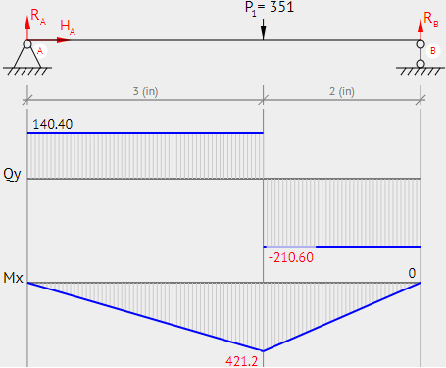
Y-Direction:
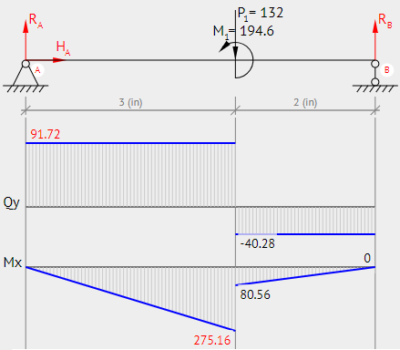

(C)
Bending Moment at the Left:
$$M_{B}=\sqrt{{275.16}^{2}+{421.2}^{2}}=503.11$$
Bending Moment at the Right:
$$M_{B}=\sqrt{{80.56}^{2}+{421.2}^{2}}=428.835$$

(D)
From appendix 3: $S_{u}=61, S_{y}=51$
From Fig 5-11a:$S_{n}≅23 ksi$
$$S_{n}^{'}=s_{n}*C_{m}*C_{st}*C_{R}*C_{s}=23*0.81*0.9*1*1=16.767 [ksi]$$
$$D_{Left}={\left(\frac{32*N}{π}*\sqrt{{\left(\frac{K_{t}M}{s_{n}^{'}}\right)}^{2}+\frac{3}{4}{\left(\frac{T}{s_{y}}\right)}^{2}}\right)}^{1/3}={\left(\frac{32*3}{π}*\sqrt{{\left(\frac{2*503.11}{16767}\right)}^{2}+\frac{3}{4}{\left(\frac{0}{51000}\right)}^{2}}\right)}^{\frac{1}{3}}=1.224\left[in\right]$$
$$D_{Right}={\left(\frac{32*N}{π}*\sqrt{{\left(\frac{K_{t}M}{s_{n}^{'}}\right)}^{2}+\frac{3}{4}{\left(\frac{T}{s_{y}}\right)}^{2}}\right)}^{1/3}={\left(\frac{32*3}{π}*\sqrt{{\left(\frac{2*428.835}{16767}\right)}^{2}+\frac{3}{4}{\left(\frac{726.7455}{51000}\right)}^{2}}\right)}^{\frac{1}{3}}=1.172\left[in\right]$$

4. A helical compression spring with free length of 68 mm needs to carry a load of 500 N with a deflection of 25 mm. The spring index can be taken as 8. Assume the following values for spring material: the resultant maximum shear stress 𝜏max = 350 MPa and shear modulus of elasticity 𝐺 = 84 GPa. Design this spring by specifying following: (5’ in total)
1) wire diameter (𝐷𝑤)
2) mean diameter (𝐷𝑚)
3) number of active coils (𝑁𝑎)
4) total number of coils (𝑁) assuming squared and ground ends
5) solid length of the spring (𝐿𝑠)
6) pitch of the spring (𝑝)
Given: $L_{f}=68;F=500;f=25;C=8;τ=350MPa;G=84GPa$
$$K=\frac{4C-1}{4C-4}+\frac{0.615}{C}=\frac{4*8-1}{4*8-4}+\frac{0.615}{8}=\frac{13261}{11200}≅1.184$$
$$τ=\frac{8KFC}{πD_{w}^{2}}→350*{10}^{6}=\frac{8*500*8*\frac{13261}{11200}}{π*D_{w}^{2}}→D_{w}≅0.00587=5.87mm$$
$$C=\frac{D_{m}}{D_{w}}→8*0.00587=D_{m}=0.04696=46.96mm$$
$$F=\frac{f*G*D_{w}}{8*C^{3}*N_{a}}→500=\frac{25*{10}^{-3}*84*{10}^{9}*0.00587}{8*8^{3}*N_{a}}→N_{a}≅6.02≅6$$
$$N_{a}=N-2→N=6+2=8$$
$$L_{s}=N*D_{w}=8*5.87mm=46.96mm$$
$$L_{f}=p*N_{a}+2*D_{w}→68*{10}^{-3}=p*6+2*0.00587→p=9.376mm$$

5. A support bar for a machine component is suspended to soften applied loads. The mean diameter of the spring must be 3.00 in. The installation length of the spring is 3.00 in and corresponding force is 180 lb. During operation, the load on the spring is 220 lb with the position of the rod is to move 0.50 in. Several million cycles of load application are expected. Use ASTM A229 steel wire. The type of end condition is squared and ground ends. Design a standard helical compression spring by specifying following: (20’ in total)
1) wire diameter, mean diameter, spring index, Wahl factor
2) OD, ID, free length
3) solid length and corresponding force
4) number of active coils and total number of coils
5) determine actual design stress
6) check the maximum shear stress at the operating load and at the solid length condition

From table 18-4: $G=11.2*{10}^{6}$
Data: $F_{1}=180;F_{O}=220;L_{O}=2.5;L_{1}=3;D_{m}=3$
We are using Severe service
$$k=\frac{F_{O}-F_{1}}{L_{1}-L_{O}}=\frac{220-180}{3-2.5}=80$$
$$L_{f}=\frac{F_{O}}{k}+L_{O}=\frac{220}{80}+2.5=5.25$$
With C between 5-10, (Table 18-8)
$$7.5=\frac{D_{m}}{D_{w}}→7.5=\frac{3}{D_{w}}=0.3-0.6in$$
Trial wire diameter: 0.4
$$Stress=75 ksi$$
$$K=\frac{4C-1}{4C-4}+\frac{0.615}{C}=\frac{4*7.5-1}{4*7.5-4}+\frac{0.615}{7.5}=1.19738≅1.20$$
$$D_{w}=\sqrt[3]{\frac{8*K*F*D_{m}}{π*τ_{max} }}=\sqrt[3]{\frac{8*1.2*220*3}{π*75000}}=0.3$$

The closest Wire gage is 0.3065
Checking Design stress with the new wire gage
$$C=\frac{D_{m}}{D_{w}}=\frac{3}{0.3065}=9.788$$
$$K=\frac{4C-1}{4C-4}+\frac{0.615}{C}=\frac{4*9.788-1}{4*9.788-4}+\frac{0.615}{9.788}=1.1482$$
$$τ_{max}=\frac{8*K*F_{O}*D_{m}}{π*D_{w}^{3}}=\frac{8*1.1482*220*3}{π*{0.3065}^{3}}=67020<75000$$
$$N_{a}=\frac{fGD_{w}}{8FC^{3}}→\frac{G*D_{w}}{8*k*C^{3}}=\frac{11.2*{10}^{6}*0.3065}{80*8*{9.788}^{3}}=5.72≅6$$
$$N=6+2=8$$
$$L_{s}=N*D_{w}=8*0.3065=2.452$$
$$F_{s}=k\left(L_{f}-L_{s}\right)=80*\left(5.25-2.452\right)=223.84$$
$$τ_{s}=τ_{max}\left(\frac{F_{s}}{F_{O}}\right)=67020\left(\frac{223.84}{220}\right)=68189.8$$
$$OD=D_{m}+D_{w}=3+0.3065=3.3065in$$
$$ID=D_{m}-D_{w}=3-0.3065=2.6935in$$
If $\frac{L_{f}}{D_{m}}>5.2$, then buckling will occur
$\frac{5.25}{3}<5.2$, so buckling will not occur
$$CC=\frac{L_{O}-L_{S}}{N_{a}}=\frac{2.5-2.452}{6}=0.008$$

6. A pair of spur gears with 25°, full-depth, involute teeth transmits 50 hp. The pinion is mounted on the shaft of an electric motor operating at 1150 rpm. The pinion has 18 teeth and a diametral pitch of 5. The gear has 68 teeth. Compute the following: (5’ in total)
1) The rotational speed of the gear
2) The velocity ratio and the gear ratio for the gear pair
3) The pitch diameter of the pinion and the gear
4) The center distance between the shafts carrying the pinion and the gear
5) The pitch line speed for both the pinion and the gear
6) The torque on the pinion shaft and on the gear shaft
7) The tangential force acting on the teeth of each gear
8) The radial force acting on the teeth of each gear
9) The normal force acting on the teeth of each gear

$$n_{G}=\frac{n_{P}N_{P}}{N_{G}}=\frac{1150*18}{68}=\frac{5175}{17}≅304.4 \left[rpm\right]$$
$$VR=\frac{n_{p}}{n_{G}}=\frac{N_{G}}{N_{P}}=\frac{68}{18}≅3.77778$$
$$m_{G}=\frac{N_{G}}{N_{P}}=\frac{68}{18}≅3.77778$$
$$D_{G}=\frac{N_{G}}{P_{d}}=\frac{68}{5}=13.6\left[in\right]$$
$$D_{P}=\frac{N_{P}}{P_{d}}=\frac{18}{5}=3.6[in]$$
$$C=\frac{{D_{P}+D}_{G}}{2}=\frac{13.6+3.6}{2}=8.6\left[in\right]$$
$$v_{t}=\left(\frac{D}{2}\right)ω=\frac{πD_{p}n_{p}}{12}=\frac{π*3.6*1150}{12}=1083.85\left[\frac{ft}{min}\right]$$
$$T_{P}=63000\left(\frac{P}{n_{P}}\right)=63000\left(\frac{50}{1150}\right)=2739.13\left[lb⋅in\right]$$
$$T_{G}=63000\left(\frac{P}{n_{G}}\right)=63000\left(\frac{50}{304.4}\right)=10348.2\left[lb⋅in\right]$$
$$W_{t}=\frac{\frac{T_{P}}{D_{P}}}{2}=\frac{2739.13}{\left(\frac{3.6}{2}\right)}=1521.7388\left[lb\right]$$
$$W_{r}=W_{t}*\tan\left(θ\right)=1521.7388*\tan\left(25\right)=709.6\left[lb\right]$$
$$W_{n}=\frac{W_{t}}{\cos\left(θ\right)}=\frac{1521.7388}{\cos\left(25\right)}=1679.05[lb]$$
7. Devise a gear train using all external gears on parallel shafts. Use 20° full-depth involute teeth and no less than 16 teeth and no more than 150 teeth in any gear. The input speed is 1800 rpm and the output speed must be exactly 2.0 rpm. Ensure that there is no interference. Sketch the layout for your design. (10’ in total)
$$TV=\frac{input}{output}=\frac{1800}{2}=900$$
$$VR_{max}=\frac{N_{max}}{N_{min}}=\frac{150}{16}=9.375$$
$$Factors:2,2,3,3,5,5$$
$$Three Pair:VR={\left(9.375\right)}^{3}=823.97$$
$$Four Pair:VR={\left(9.375\right)}^{4}=7724.762$$
N_{A}=16 | 6 | N_{A}=16 | 6 | N_{A}=16 | 5 | N_{A}=16 | 5
N_{B}=96 |  | N_{B}=96 |  | N_{B}=80 |  | N_{B}=80

$$\frac{80}{16}*\frac{80}{16}*\frac{96}{16}*\frac{96}{16}=900$$

*Not to Scale
